**Trading**

Started Dec 5, 2022

***Keywords:***

CMP – Current Market Price

BV – Book Value check in Money control app

FV-Fair Value = BV*5 or BV*10

B/O = Breakout- Happens when candle / market breaks the upper side of the marked region

B/D = BreakDown - Happens when candle / market breaks the lower side of the marked region

Consolidation – Atleast few candles should travels in sideways for a short period of time

***What is share market?***

Place where we can buy, hold and then sell assets in digital format in a particular period. When any company wants to raise a fund by selling the portion of ownership in the form of shares once they get approval from SEBI through IPO.

SEBI – Security Exchange Board of India

IPO – Initial Public Offer

~ Min 1Lot = 6 to 25 and Price ~15000 rupees

Apply for IPO during the open period and you will get notification within 7 days if they company is fundamentally strong.

**Who Organize SM**

* SEBI

Since ppl can’t buy the shares from the companies directly, we need an exchange to handle it. On top of we should have trading account and demat account from the stock brokers.

Ex: Zerodha, Groww, 5 paisa and HDFC demat account service.

**Where can we buy stocks /shares?**

IN INDIA –

* NSE – National stock Exchange (Bigger in size/no of companies) ->NIFTY50 #50 represents Top 50 companies performance
* BSE – Bombay Stock Exchange (Legacy) -> SENSEX (30) #30 represents top 30 companies’ performance

***Thumb Rules in Share Market:***

1. No one knows who controlling /functioning share market is, because there are millions of people in INDIA investing and trading in sharemarket which includes retail investors (Common man) and Big Bulls.
2. No “Strategy” will work 100% in sharemarket, it’s a matter of time and experience we gain by practicing in live market using many factors.
3. Practice more not just only to make profit but also minimize the loss.

***Points to remember while trading:***

1. Save your hard-earned money as a capital to invest and trade (60% max)
2. No “Strategy” will work 100% in sharemarket
3. Trading is **NOT to** get rich quickly but one day
4. Use compounding effect to make progress gradually
5. Making Loss and Profit is common. Mentally needs to be strong
6. Don’t put all the eggs in one basket, diversify your money into different sectors to minimize the loss.

***Types of trading:***

***InVestment 🡪*** Buy quality stocks after the technical and fundamental analysis and Hold it for longer period -> Long term (year on year growth) -> Low risk

* Short term – 1+ Year
* Mid-term – 4-7 years
* Long term – 10+ years

***Swing Trade 🡪***  Buy and Hold it for more than a day, Trades last for days, weeks sometimes even months if it goes in a predicted direction -> Less Risk

***Intraday 🡪***  buy and sell within a same day 🡪Risky

***Scalping 🡪*** With in a same day, Trade ends in hours, Minutes even seconds -> High risk

***Future and Options 🡪*** Highly risky and highly rewarded

**How to choose stocks for investment?**

**Promoter holding:** Check in any website like moneycontrol or screener. It should be more than 35% (40 + or – 5%)

**Pledge:** Below 10% Else Avoid

3 Types

1. UnderValue Stocks :-

Stocks that are fundamentally strong and has a hope of going in good position in future.

Condition: CMP < BV AND CMP<BV<FV

Term = Mid and Long Term

1. Attractive stocks: -

Stocks that are fundamentally strong and has a hope of going in good position in future for short period.

Condition: CMP>BV AND FV>CMP>BV

Term = Short and Mid

1. OverValue stocks: -

Stocks that are fundamentally strong and already in good position can be hold for short period. Recommended to Avoid.

Condition: CMP<<FV

Ex: CMP=3000 BV=135 FV=135*10=1350

**Technical Analysis of any stock**

Various ways to analysis: -

1. Trend (Up / Down/ Sideways)
2. Candlesticks (combinations of Green and Red Candles)
3. Chart Patterns
4. **Support and resistance - Price Action**
5. **Multiple time frame analysis**
6. Indicators

***Trends***

**Uptrend:**

**Downtrend**

**Sideways**

**Candlesticks -> Get the PDF & photos from Iphone and copy here**

Green or Red in color which indicates the action /movement of the stock/market in a particular time period

Body = Closing point – Opening point

Wick = Uncovered or max and min point of the candle

***Bull /Upside movement***

***Bear/Downside movement***

**Chart Patterns**

* Patterns indicates the possible movement in the market. Take entry only when its in trend NOT in consolidation
* Patterns may not be same as theoretical pattern
* In any pattern, wait for the candle to close and new candle is formed after that check B/O or B/D happens before taking ENTRY

***Head and Shoulders***

***Left shoulder-Head-Right Shoulder ->Breakdown ->DownTrend***

***Inverted Head and Shoulders***

***Left shoulder-Head-Right Shoulder ->Breakout ->UpTrend***

***Cup and Handle***

***Handle ->Breakout ->UpTrend***

***Handle and Cup***

***Cup ->Breakout ->UpTrend***

***Inverted Cup and Handle***

***Handle ->Breakdown ->DownTrend***

**Reversal Patterns**

**‘M’ Pattern**

**After close ->B/D ->Downtrend**

**‘w’ Pattern**

**After close ->B/O ->Uptrend**

**Harami**

When one big candle covers or swallow min of two candles within its body called Harami. Where the colour of big and small candles doesn’t matter.

Can leads to B/O or B/D depends on the trend

**Bullish flag**

***Uptrend -> sideways ->Breakout ->Uptrend***

***Bearish flag***

***Downtrend -> sideways ->Breakdown ->Downtrend***

**Support and Resistance**

**4 Types**

1. **S Gives S**

If a stock can’t B/D the support line more than one time and give a strong BULL signal there is chance of uptrend

1. **R Gives R**

If a stock can’t B/O the Resistance line more than one time and give a strong Bear signal there is chance of trend

1. **S Gives R**

Once stock breakdown the support level and form bear signal then the same S level act as a R for next SR

1. **R gives S**

Once stock breakout the resistance level and form bull signal then the same R level act as a S for next SR

**Obvious Support & Resistance**

* Support -> Wait for the stock to touch the support line 2 times. If it touches the ‘s’ line 3rd time with bull (+ve) sign then it should be Uptrend
* Resistance -> Wait for the stock to touch the resistance line 2 times. If it touches the ‘R’ line 3rd time with bear (-ve) sign then it should be downtrend

***Charts***

***Day 2 -6 December 2022***

***Level Marking – High Accuracy***

***Rules:***

*Mark the CMP and Draw an imaginary line for reference, which touches multiple points in the past few days. Consider the points after reversal.*

1. *Use 15 mins TF for intraday / 1hr for swing*
2. *Mark 2 levels above CMP and 2 levels below CMP*
3. *Do not draw lines too near to the CMP*
4. *3 levels are also good enough*
5. *Difference amount between any two should be 80-100 for options and 35+ for equity*

***Swing Trade***

Less Risk and can invest high amount

Hold stocks for days/ weeks/ months

**Rules :**

1. **TF = 1Hr /1 day**
2. Strategy => Should break the nearest resistance from the CMP
3. Stock selection

***Sectoral analysis*** -> Moneycontrol ->Indices->Sectoral Indices => Nifty bank, nifty auto, nifty pharma and nifty FMCG.

* 1. If the Indices goes uptrend then most of the stocks under this indices should also go in the same direction
  2. Open the same indices or stocks in Tradingview for technical analysis

**Scanner ->** % change in the market of any stock should not be more than 6%. Use chartink website

Entry for swing trade

**Aggressive: If there is a strong B/O or B/D happens between 3.20 to 3.30PM, coz in last 10 mins it won’t fluctuate too much**

**Conservative: Mark last day HIGH, if today market open higher than the previous day then consider that as a entry.**

***Trends Lines***

How to draw a trending lines in different trends ?

**Uptrend:** Draw a line at the bottom of the uptrend and consider that as a support

**Downtrend :** Draw a line at the top of the downtrend and consider that as a resistance

**Triangle Line:** If you can draw the lines on both sides then its considered as triangle

***Trends Lines – B/O and B/D***

If B/O or B/D happens at 3rd point in any trendline consider that as an entry in opposite side

Downtrend -> Breakout the resistance after 2 touch points-> Uptrend

Uptrend -> Breakdown the support line after 2 touch points ->Downtrend

***Trends Lines – Reversal***

If B/O or B/D happens at 3rd point in any trendline consider that as an entry in the same side

DownTrend -> Doesn’’t B/O R -> Downtrend

Uptrend -> Doesn’t B/D the S -> Uptrend

Day 5

Scalping

Heiken Ashi (1 to 3 mins TF)

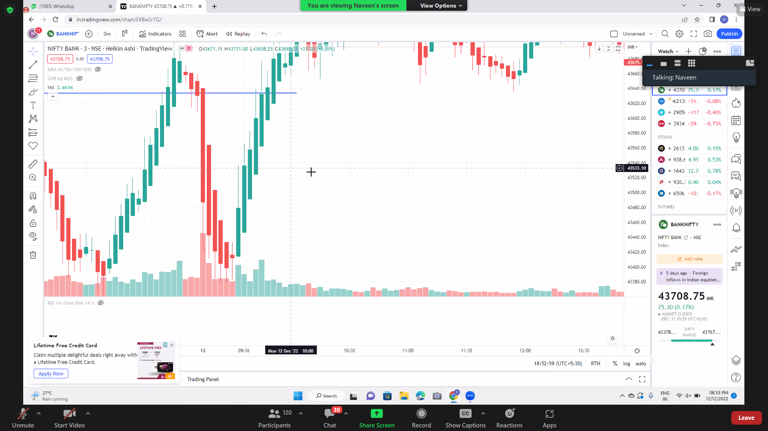

After continuous 2 candles whether green or red, then next should be the same trend, that entry must be opening of 3rd candle..

Set stoploss at the bottom of 2nd candle and target should be same as SL. SL == min point of target.

For Uptrend = buy at 100 SL should be 90 and target 110 min (max 30-40 points)